

**American International University- Bangladesh**

**CSC 2209: Object Oriented Programming 1 (JAVA)**

**CO1 Evaluation**

**Project Summary Report**

**Summer 18-19**

**Group No: K08**

**Project Title: Car Parking Management System**

|  |  |
| --- | --- |
| Student Name | Student Id |
| Rahman, Mashiur | **17-35683-3** |
| Amlan, Syed Afridi Rahman | **17-35630-3** |
| Readoy, Yeasin Arafat | **17-35870-3** |
| Rikta, Sanzida Afroze | **17-34625-2** |

**Introduction:**

This project is developed for parking car. The Parking Management System provides electronic monitoring and management of parking facilities. This project is to store information of management system, where the information of the cars and employees are being stored associated with the parking system.

**User Category:**

There are two types of Users here. They are:

* Operator
* Manager

**Feature List:**

In this project the “Operator” has the following features:

* Login
* Insert Data
* Update Data
* Delete Data
* Search Data
* View Car Information

In this project the “Manager” has the following features:

* Login
* View All Information
* Manage Employees
* Insert, Update, Delete, Search Data

**GUI Description:**

Give a screen shot of some GUIs and write a very small description (Maximum 40 words) for each of the GUIs.

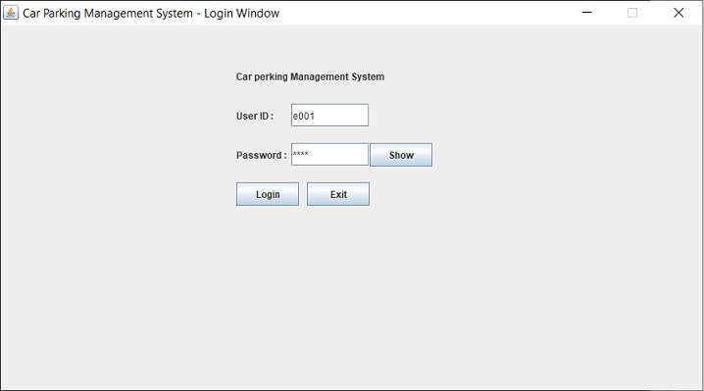

This is login Frame, where a user insert there user ID & password to login to the system. There is Exit button to exit the program and show button to view password.

**Database Table Description:**

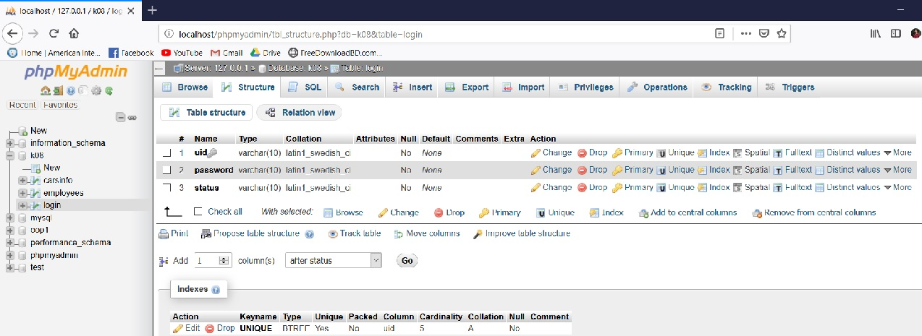

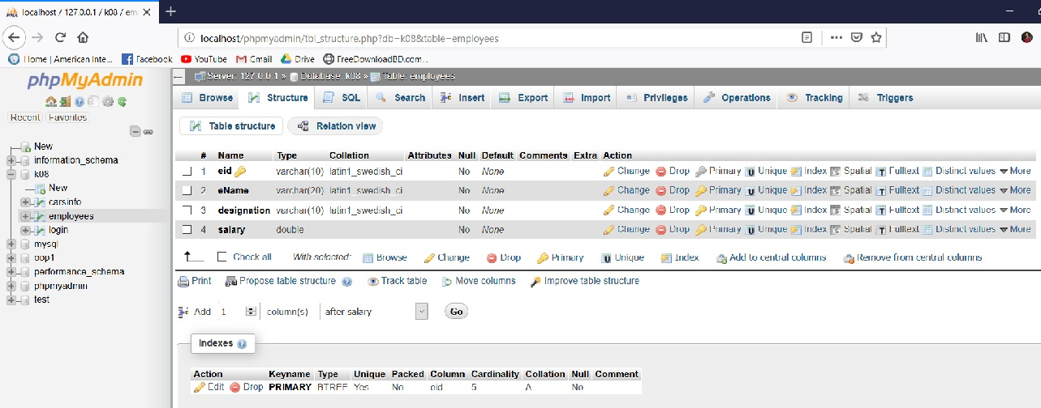

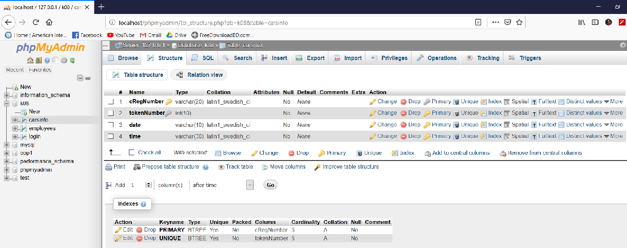

**Class Diagram:**

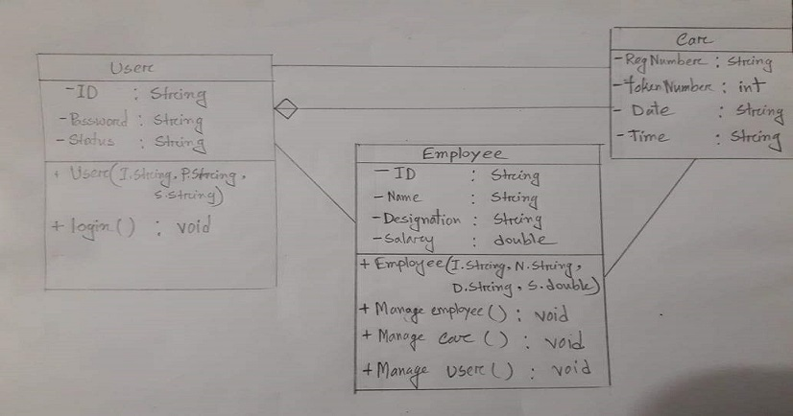

**Tools Used:**

To develop this project we have used the following:

* Xampp
* Notepad++

**OOP and Java Concepts Used:**

* Encapsulation: Encapsulation is the mechanism of binding one attribute with a method. It is done, so that we can not access the attribute directly.
* Inheritance: Inheritance is the mechanism of creating a new class from an existing class. The keyword **extends** is used to denote inheritance.
* Interface: Interface is just like an abstract class where all the methods are abstract. It is denoted with the keyword **interface**.
* GUI: GUI means Graphical User Interface.

**Impact of this Project:**

What impact this project will have on the society and economy?

* The system is made more efficient as vehicle travel time and search time are significantly reduced due to the information provided by the smart parking system. With the information provided, drivers are able to avoid car park that are fully occupied and locate vacant parking spaces with ease elsewhere.

How will people be benefitted from your project?

* Increased Protection. With its technologically advanced security features, parking management systems can give you upgraded security, safety and privacy. Parking management systems prevent unauthorised access to your parking lots, as a result, car owners will have increased confidence that their cars are well protected

**Limitations and Possible Future Improvements:**

**Limitations:**

1. It may be a bit confusing for unfamiliar users.

2. It requires a maintenance contract with the supplier

3. There may be a fear of breakdown (How do I get my car out?)

**Possible Future Improvements:**

1. Artificial intelligence can be added to the system.

2. Payment method can be added to the system.

3. Booking method can be added to the system for online booking.